### Design and Analysis of Algorithms Assignment - 7

###### Name: Dhanraj Kore

###### Div: TY B

###### Roll No: 60

###### Batch : B-3

**Conflict free Job Scheduling**

**CODE :**

#include<bits/stdc++.h>

using namespace std;

bool helper(pair<int,int> p1,pair<int,int> p2)

{

    return p1.second<p2.second;

}

int main()

{

    int n;

    cout<<"Enter the no. of jobs : ";

    cin>>n;

     vector<pair<int,int>> v(n);

    cout<<"Enter the starting time and ending time of each job:  "<<endl;

    for(int i=0;i<n;i++)

    {

        cout<<"Job "<<i<<" : ";

        cin>>v[i].first>>v[i].second;

    }

    sort(v.begin(),v.end(),helper);

    cout<<"The job sequence should be : "<<endl;

    cout<<"Starting Time "<<" Ending Time"<<endl;

    cout<<v[0].first<<'\t'<<v[0].second<<endl;

    int temp = v[0].second;

    for(int i=1;i<n;i++)

    {

        if(v[i].first>=temp)

        {

             cout<<v[i].first<<'\t'<<v[i].second<<endl;

             temp = v[i].second;

        }

    }

}

**O/P:**

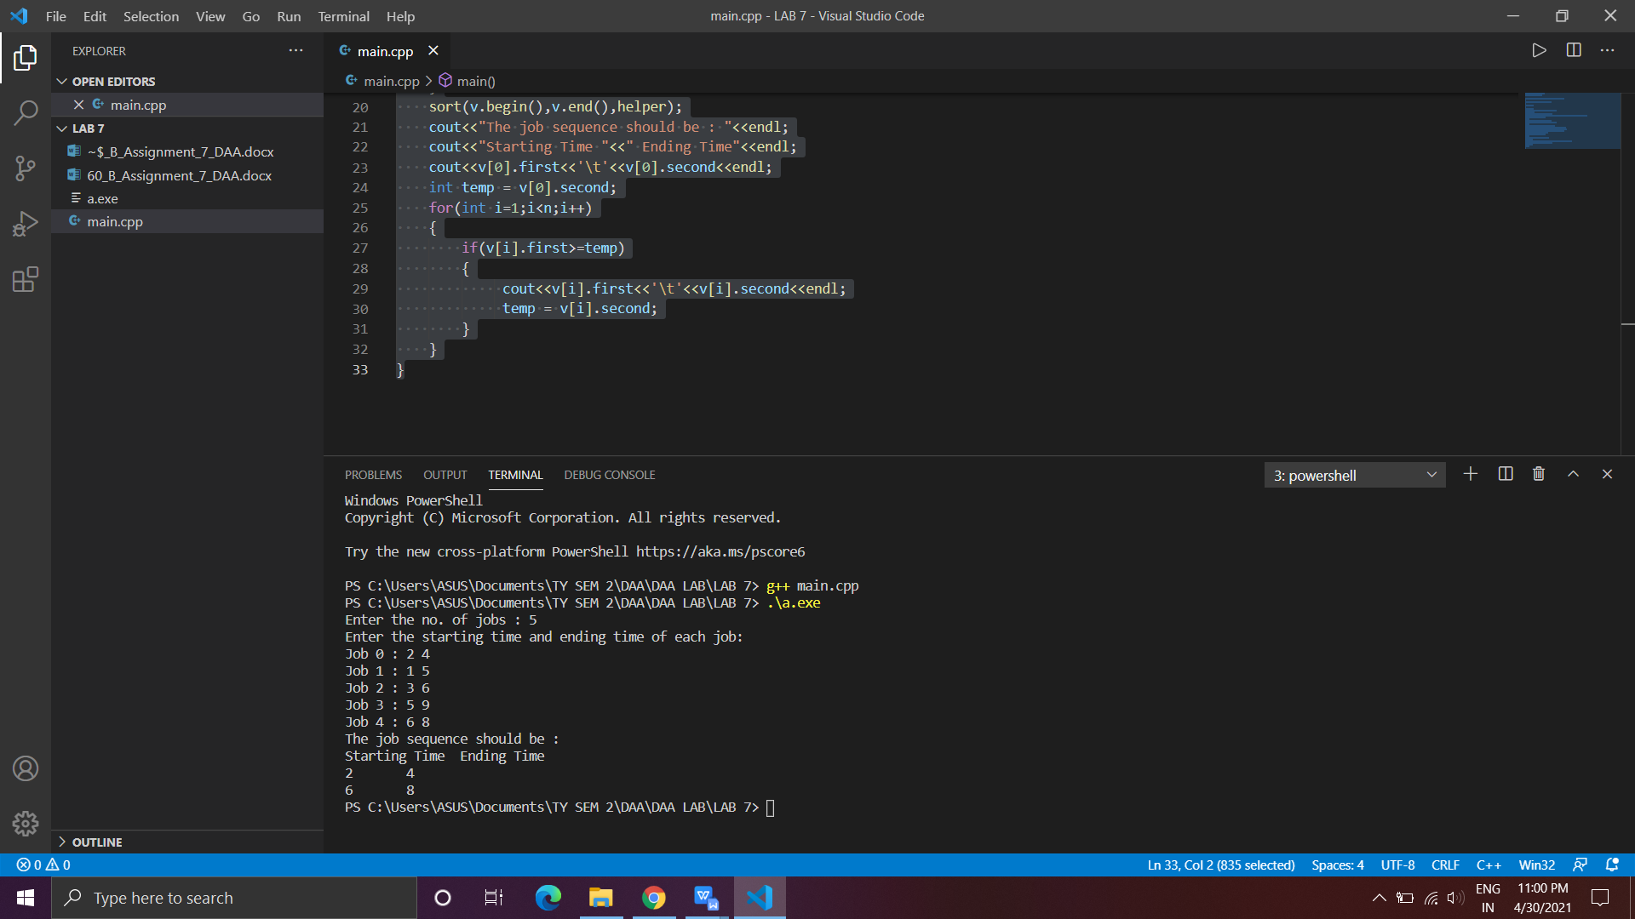

**Time Complexity:** **O(nlogn)**

**Space Complexity:** **O(1)**